Project Documentation

1. Open the solution file
2. Make sure to change the path of customer, fleet and rental path to it’s relevant path within then host computer.
3. To build the project press F5
4. From there a UI interface will appear giving the user 3 options to choose from
5. 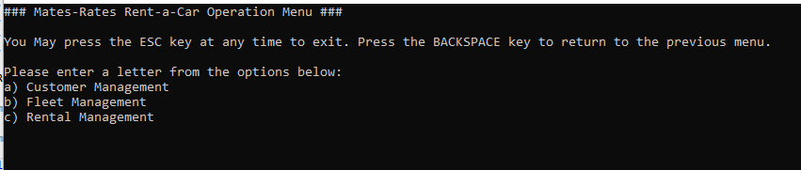
6. Typing the letter a will bring the user to the customer management section
7. 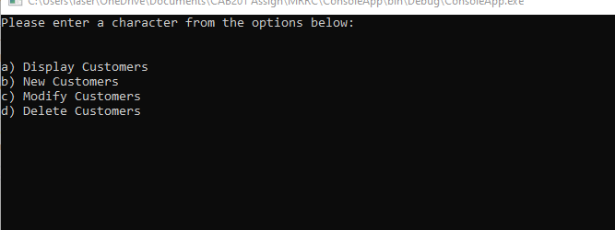
8. From there, there are 4 options the user can enter a to display data from a csv file or they can enter b and add a new customer
9. If the user had gone to the fleet management section then they can get another 4 options
10. 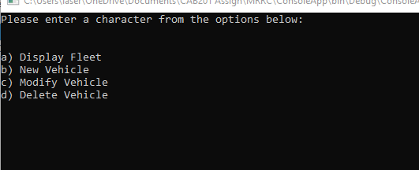
11. Allowing them to display the fleet of vehicles or add a new vehicle to the list
12. If the user entered c then they’ll be taken to rental management
13. 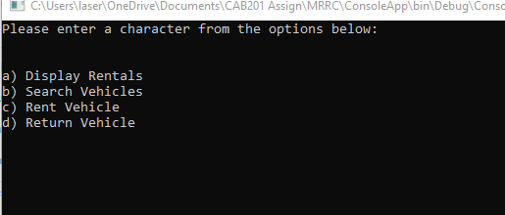
14. From there they can enter a in order to display all the vehicles that are being rented and the customer identification number of the customer who is currently using it.